TECHNICAL PROJECT REPORT

Title of Project: Blind navigation cap

Team Members / Inventors:

|  |  |  |  |  |  |
| --- | --- | --- | --- | --- | --- |
| **S. No.** | **Name** | **Department** | **Designation** | **Mobile** | **E-Mail** |
| 1. | Akarshit Patel | CSE(AI&ML) | Student | 884037378 | hrishi007patel@gmail.com |
| 2. | Uday Juneja | CSE(AI&ML) | Student | 9831560682 | junejauday@gmail.com |
| 3. | Aniket Kumar | CSE(AI&ML) | Student | 9304691242 | Aniketkumar.9530@gmail.com |
| 4. | Khushal Thakur | ECE | Mentor | 9646030764 | khushal.thakur@cumail.in |
| 5. | Anshul Sharma | ECE | Mentor | 9478697475 | anshulsharma.ece@cumail.in |
| 6. | Kiran Jot Singh | ECE | Mentor | 9463909689 | kiranjotsingh.ece@cumal.in |
| 7. | Divine Singh Kapoor | ECE | Mentor | 9878422653 | divneet.ece@cumail.in |

Section – 1 (IPR Related)

# Brief ABSTRACT:

BLIND NAVIGATION CAP

This project aims at helping the blind to detect obstacles at a distance up to 1 meter. The buzzer will beep according to the distance such as:

Distance between 100-75 the buzzer will beep on for delay of 100ms.

Distance between 75-50 the buzzer will beep on for delay of 400ms.

Distance between 50-25 the buzzer will beep on for delay of 700ms.

Distance between 25-0 the buzzer will beep on for delay of 1000ms.

A stick with a vibrating motor installed in it can serve as modification as it will give the blind person a regular report of the obstacles which are lying or coming at his leg level.

# Existing state-of-the-art and Drawbacks in existing state-of-the-art

|  |  |  |
| --- | --- | --- |
| **S. No.** | **Existing state of art** | **Drawbacks in existing state of art** |
| 1 | General stick | There is nothing that can tell them that at what distance the obstacle is. |

# Novel/Additional modifications that you can propose to improve upon drawbacks

# Disadvantages

* The person needs to rotate his/her head to get the information about the surrounding.
* It would not work against fast moving objects.

# Advantages

* The blind person will get the pre-information of the obstacle which are around him/her.
* Easy to use.
* It cannot easily have malfunctioning because its circuit is easy and simple.
* Works on less electricity as uses only 9V battery.

Block Diagram

Switch

Buzzer

Ultrasonic sensor

+ve-6

-ve-GND

Arduino Nano

ECHO-12

GND-GND

Battery

TRIG-13

VCC-5V

Section – 2 (Real Project)

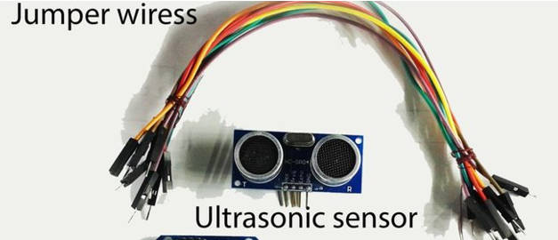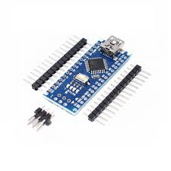[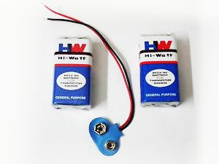](https://cdn.instructables.com/FJF/WAGL/IQ2KBLCJ/FJFWAGLIQ2KBLCJ.LARGE.jpg)

**Here are the parts you need to collect:**

|  |  |  |  |
| --- | --- | --- | --- |
| **S. No.** | **Component** | **Quantity** | **Price** |
| 1. | Ultrasonic sensor | 1 | 150/- |
| 2. | Arduino Nano | 1 | 320/- |
| 3. | Battery | 1 | 20/- |
| 4. | Nano Connecting Wire | 1 | 100/- |
| 5. | Jumper Wires | 20 | 50/- |
| 6. | Toggle Switch | 1 | 20/- |
| 7. | Buzzer | 1 | 20/- |
| 8. | Cap | 1 | 100/- |
|  | **TOTAL** |  | 780/- |

**Step one:**

* Connect the of Ultrasonic Sensor to GND of Arduino Nano and TRIG pin to pin no. 13 and ECHO to 12.
* Now connect +ve end of buzzer to 6 no. pin and -ve end to GND in Arduino Nano.
* Finally, we have to connect +ve of battery to switch and then to Vin while -ve is connected into GND.

**Step two:**

* Put the setup on the cap for testing.

**Step three:**

* Put it in the cap, and it is ready for use

**Initial Testing Model:**

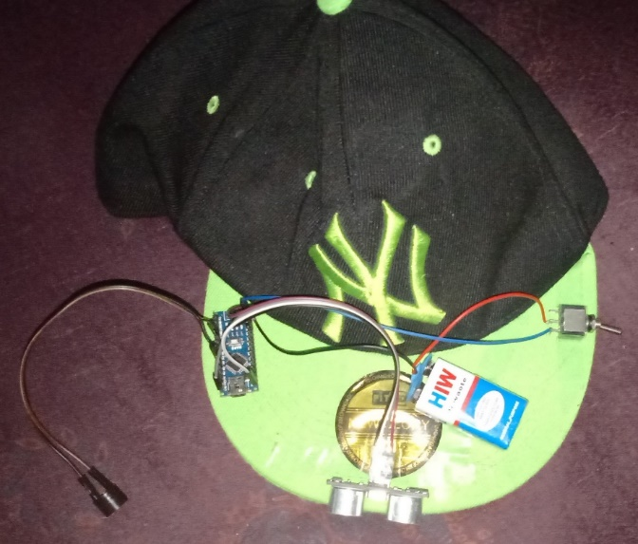

**Final Representing model:**

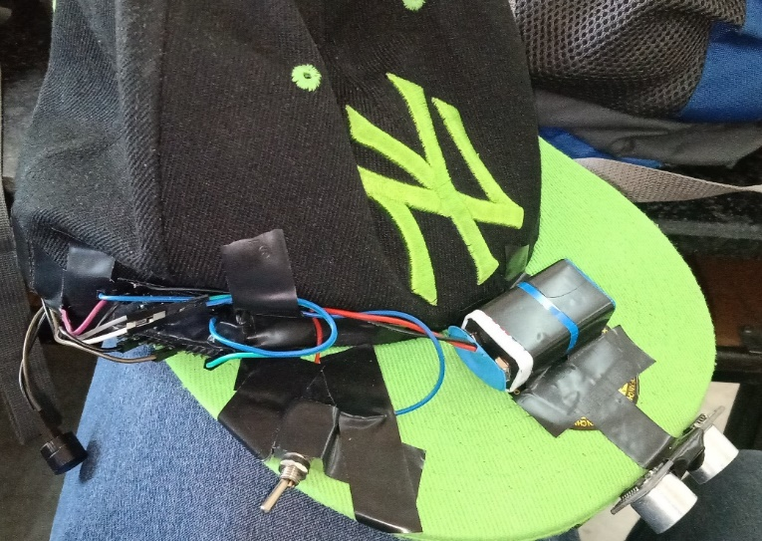

# Program Code

**GITHUB code link:** **https://github.com/UJ09/Blind-navigation-cap**